Terms of Reference
Book Delivery and Program Implementation
Read@Home – North Macedonia

Context
Results of the PISA 2022 reading results reveals a critical need for strategic educational development, as the proficiency level of 15-year-old students in North Macedonia currently lags behind international benchmarks. Only 26% of students achieved at least Level 2 proficiency in reading—the level required to manage simple tasks like identifying the main idea in a text drastic shortfall compared to the OECD average of 74%. Furthermore, almost no students scored at the highest levels (Level 5 or 6), versus 7% across the OECD, and average reading scores declined compared to 2018.

Addressing these deficits requires focusing on early childhood (ages 0-6 years), the critical period for brain and language development. Strong pre-literacy skills established during this time are essential for later reading success. Early interventions are more cost-effective than remediating difficulties later.

Significant learning disparities linked to family background arise before formal schooling, with gaps in language exposure and access to learning materials. Caregivers/parents play a vital role as children’s first teachers, providing personalized language exposure vital for school readiness, especially where formal education is limited.

The Read@Home program leverages parents/caregivers by providing books, stimulating materials, and practical workshops on shared reading. This early intervention aims to reduce inequalities, prevent learning difficulties, and foster children’s love of learning.

Project Overview
The Read@Home program will provide children across eight North Macedonian municipalities with age-appropriate books selected from open-access resources. These materials will be tailored for two distinct age groups: 0–3 years (focusing on sensory stimulation, simple language, and durability) and 4–6 years (targeting pre-literacy skills, vocabulary, and narrative comprehension). The program will prioritize families receiving Guranteed Minimum Assistance (GMA)/Child Allowances in the following municipalities: (1) Arachinovo, (2) Bitola, (3) Prilep, (4) Saraj, (5) Skopje-Chair, (6) Skopje-Shuto Orizari, (7) Studenichani, and (8) Tetovo.
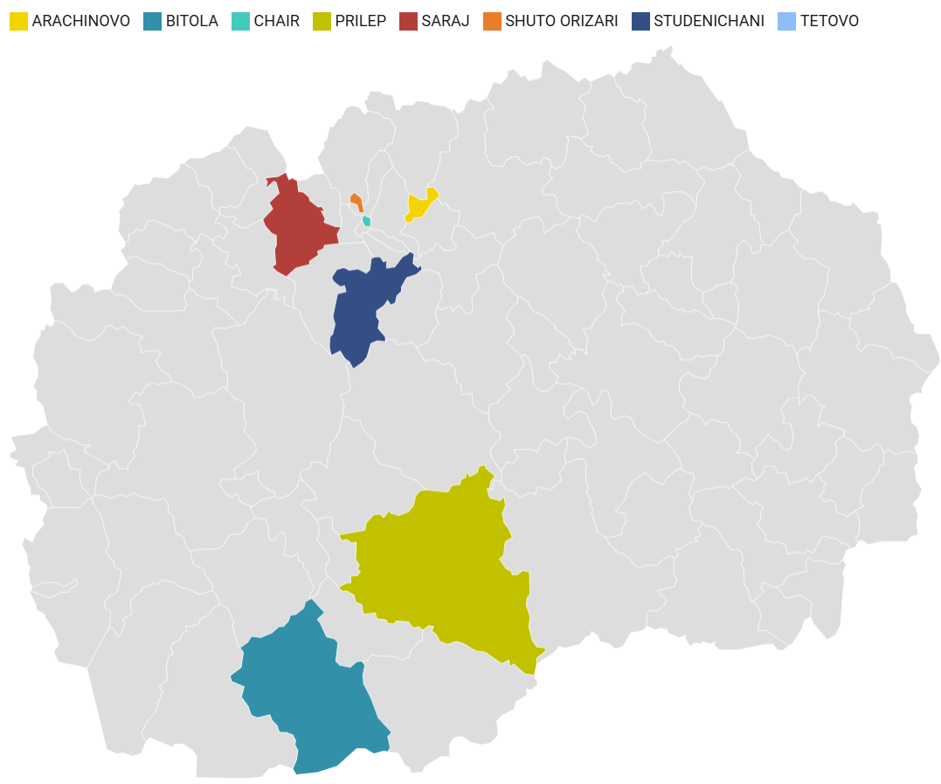

In addition to receiving books, parents will be invited to attend parent workshops hosted by facilitators trained in the Read@Home curriculum. Separate workshops will be conducted for each age group over a four-week period. To reinforce learning, parents will receive weekly text messages throughout the duration of the course. The in-person parent workshops will be delivered during Week 1 and Week 3.

The parent workshops will introduce foundational concepts to teach caregivers how to effectively initiate book-sharing activities, expand their children's vocabulary through shared reading, and ensure interactions remain fun and engaging. Furthermore, the sessions will focus on fostering comprehension and basic emotional literacy. Parents will learn how to bridge the stories in the books with their children’s personal experiences, utilizing narratives to help their children understand and express various emotions.

To ensure continuous engagement outside of the in-person sessions, parents will receive supportive text messages throughout the program. These messages will serve as regular prompts for parents to engage in shared reading with their children. Furthermore, the SMS content will encourage them to apply the specific techniques and evidence-based strategies introduced during the workshops.

The parent workshops content will be developed by a Program Design Consultant, who will be appointed under a separate procurement procedure. Their primary responsibility will be to design and finalize the following core outputs:
- Comprehensive messaging frameworks for three product streams (Orientation, Parental Skills, Facilitator Support), ready to be translated to Macedonian and Albanian.
- Validated scripts for all animation and audio products.
- Content and layout drafts for all visual products, including infographics, flipbooks, and posters. These materials will be designed in accordance with low-literacy principles to ensure they are accessible and inclusive.
- Develop a detailed content outline and draft text for the Facilitator’s Guide and associated delivery guidance products

The effectiveness, feasibility, and acceptability of the Read@Home program will be evaluated through a rigorous mixed-methods study. The research will be conducted across the eight selected municipalities of North Macedonia to capture diverse geographical and socioeconomic contexts. Participating families will be invited to complete comprehensive baseline and endline assessments to measure changes in child development and parenting outcomes. To complement these quantitative findings, both families and program facilitators will be invited to participate in qualitative assessments, such as focus group discussions and semi-structured interviews. These qualitative components will be essential for understanding the lived experiences of participants and identifying barriers or facilitators to successful program implementation.

Objective and Scope of Assignment

The objective of this assignment is to support the implementation of the Read@Home program through the distribution of books, delivery of parent workshops, and administration of SMS messages.

Specifically, the assignment includes organizing and implementing door-to-door delivery of Read@Home book packages to GMA/Child Allowance beneficiary households in all targeted municipalities.

The firm will also deliver in-person parent workshops across the eight municipalities. Parents and caregivers participating in this program will receive two workshops designed to support them in using books with their children in engaging ways. The program will be structured as two manual-based group sessions, held during the first and third weeks of a four-week course. Both sessions will be led by trained facilitators and will feature interactive elements, including group discussions, live book demonstrations, and supervised practice opportunities for caregivers. Sessions will be delivered in a group format, with approximately 15–20 caregivers per group to ensure an optimal learning environment.

In addition to the in-person workshops, families will receive frequent text messages throughout the four-week period. These digital prompts will provide practical tips and reminders to reinforce shared reading habits and encourage the application of techniques learned during the sessions at home.

Scope of work
The firm will be responsible for the distribution of books and delivering the program, in accordance with the established design, to families across the eight selected municipalities. Additionally, the firm will manage the dissemination of supportive text messages throughout the intervention period. More specifically, the firm will be responsible for the following tasks:

Book delivery
    - Secure storage of books before and during delivery, and after delivery for any remaining books not delivered (for a period of 2 months after delivery).
    - Plan and implement home delivery of book packages to 250 GMA/Child Allowance-recipient families in each of the eight municipality (2000 households in total).
    - Coordinate, where necessary, with municipal Centers for Social Work or relevant authorities to verify beneficiary lists.
    - Maintain delivery tracking system and records confirming receipt of materials through signed confirmation or equivalent verification mechanisms.
    - Collect recipient information at the point of delivery,
Program workshops
    - Translate the workshops program manual and all intervention materials into local languages (Macedonian and Albanian) to ensure cultural and linguistic relevance.
    - Recruit and oversee a dedicated team of facilitators who will be responsible for the ground-level implementation of the parent workshops across the selected municipalities.
    - Conduct comprehensive training for these facilitators, focusing on both the technical Read@Home program content and essential pedagogical facilitation skills.
    - Arrange and manage all day-to-day logistics for the implementation of the parent workshops. The firm will cover all costs associated with the organization and hosting of these sessions.
    - Deliver the parent program to 80 families in each of the eight selected municipalities, reaching a minimum of 640 families across North Macedonia.
    - Conduct regular supervision of facilitators following the workshops to ensure high-fidelity implementation and maintain quality standards.
    - Collect process monitoring data during each workshop session, utilizing a standardized questionnaire that will be provided to the firm.

SMS delivery
    - Administer the SMS component by sending out supportive text messages to caregivers using a commercially available blast SMS service provider, 3 text messages per week over a period of 4 weeks, to 640 participating families throughout the four-week duration of the program. The messages will be designed by the Read@Home team in cooperation with the firm.

Qualification requirements:
The firm should hold the following relevant qualification:
- Proven track record of delivering community-based programs focused on parenting support and/or early childhood development within North Macedonia.
- Extensive experience and skills in engaging with local communities and vulnerable families with young children, particularly within diverse socioeconomic contexts.
- Demonstrated experience in the recruitment, training, and technical supervision of community-based facilitators to ensure high-quality program delivery.
- Advanced skills in monitoring program implementation and the systematic collection of process data to track fidelity and reach.
- Technical skills in using data capturing software / electronic data collection approaches.

Team requirements

The consulting firm must ensure that at least the following personnel are available to perform the tasks described above:

- Project leader/coordinator. In charge of the overall program implementation (including quality control)
Minimum qualifications:
- Masters degree in Social Sciences, Economics Human resource management, Finance, Statistics, Business Administration, Public Administration or another related field;
- Experience in implementing early childhood development and parental engagement programs;
- Minimum of six years of experience in project management;
- Experience in communicating with parents from vulnerable groups or low-literate parents/caregivers on early childhood development or education.
- Supervisor. In charge of coordinating and workshops delivery.
Minimum qualifications:
- At least a university degree;
- Previous experiences supervising large-scale parenting/community engagement programs.

- Eight Field team member.
Minimum qualifications:
- At least upper (higher) secondary school degree;
- Experience in delivering parenting/community engagement programs;
- Excellent communication skills to interact with target population;
- Proficiency in local language (Macedonian and Albanian language).

- Duration of the contract:
The duration of the assignment is 12 months

- Milestones and deliverables
The firm will be responsible for submitting the following deliverables:
- Delivery of workplan including a detailed implementation timeline, a description of the project team, and the proposed mechanisms for program implementation, facilitator supervision, and ongoing monitoring.
- Home delivery completion report, including delivery verification and coverage data for each municipality.
- Translated parent program manual and material.
- Report regarding the completed facilitator training. This report will document the completion of the training sessions, including the number of facilitators trained, an overview of the curriculum covered, and an assessment of facilitator readiness.
- The firm will submit a comprehensive workshop delivery report detailing the successful delivery of parent workshops to the targeted families across all eight municipalities.
- Process Data and Monitoring Report summarizing the completed process data collection for all sessions.
vi) A final implementation report summarizing the entire implementation process, highlighting key achievements, challenges encountered, and lessons learned during the program rollout.

- Payment schedule
The payment structure will be as follows:

- 10% upon delivery of workplan including timeline, team, proposed implementation, supervision and program monitoring mechanisms
- 20% upon delivery of translated parent program manual and material and report regarding the completed facilitator training
- 40% upon delivery of report regarding the delivered parent workshops to all families in the program across all municipalities
- 20% upon submitting report for completed process data collection
- 10% final report summarizing the process of the program implementation

- Selection Method and Contract
The selection method is " Consultant’s Qualifications Based Selection ", and the contract shall be Lump Sum according to the World Bank Procurement Regulations for Investment Project Financing (IPF) Borrowers – Procurement in IPF of Goods, Works, Non-Consulting and Consulting Services, Fifth Edition of September 2023 (www.worldbank.org).

