Terms of Reference
Data Collection
Read@Home – North Macedonia

CONTEXT
Results of the PISA 2022 reading results reveals a critical need for strategic educational development, as the proficiency level of 15-year-old students in North Macedonia currently lags behind international benchmarks. Only 26% of students achieved at least Level 2 proficiency in reading—the level required to manage simple tasks like identifying the main idea in a text drastic shortfall compared to the OECD average of 74%. Furthermore, almost no students scored at the highest levels (Level 5 or 6), versus 7% across the OECD, and average reading scores declined compared to 2018.

Addressing these deficits requires focusing on early childhood (ages 0-6 years), the critical period for brain and language development. Strong pre-literacy skills established during this time are essential for later reading success. Early interventions are more cost-effective than remediating difficulties later.

Significant learning disparities linked to family background arise before formal schooling, with gaps in language exposure and access to learning materials. Caregivers play a crucial role as children’s first teachers, providing personalized language exposure vital for school readiness, especially where formal education is limited.

The Read@Home program leverages caregivers by providing books, stimulating materials, and practical workshops on shared reading. This early intervention aims to reduce inequalities, prevent learning difficulties, and foster children’s love of learning.

OBJECTIVE AND SCOPE OF ASSIGNMENT
The Read@Home program will provide children across eight municipalities of North Macedonia with age-appropriate books selected from open-access resources for two age groups: 0-3 years (focusing on sensory stimulation, simple language, and durability) and 4-6 years (targeting pre-literacy skills, vocabulary, and narrative comprehension). The following eight municipalities have been selected based on their number of families who receives Child Allowances: (1) Arachinovo, (2) Bitola, (3) Prilep, (4) Saraj, (5) Skopje-Chair, (6) Skopje-Shuto Orizari, (7) Studenichani, and (8) Tetovo.
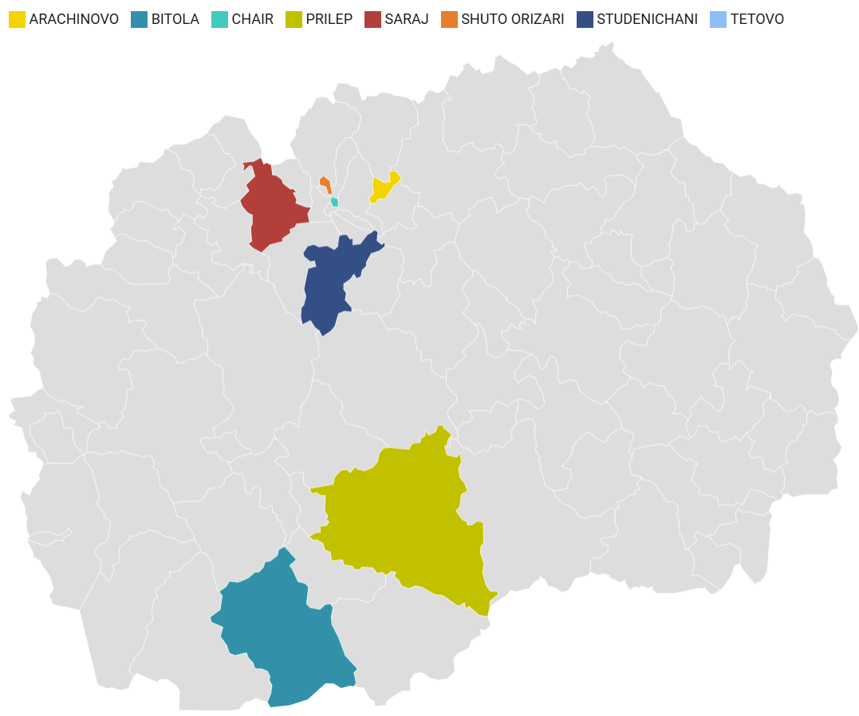

The program leverages parents as the child's first teacher through age-specific parent workshops led by trained facilitators. These workshops will teach specific shared reading techniques aimed at initiating book activities, supporting word learning, promoting comprehension, and building emotional literacy. The core learning will be reinforced via supportive text messages sent to parents as reminders to practice the techniques at home. The Read@Home program will be delivered over four weeks. Parents will receive text messages every week throughout the four weeks. Parent workshops will be delivered during week one and week three (two workshops in total).

The Read@Home program in North Macedonia will be evaluated through a mixed methods study. The study has three parts: The first part will be an effectiveness evaluation. A quantitative pre- and post-test will recruit 800 families (100 per municipalities; 50 with children aged 0-3 and 50 aged 4-6). Baseline and post-intervention assessments will measure child outcomes (pre-literacy, language, cognitive skills, engagement) and parent outcomes (knowledge, beliefs, behaviours).

The second part will be a feasibility evaluation. Feasibility will be assessed using process data collected during implementation and qualitative data from interviews and focus groups afterward. Measures include recruitment, workshops delivered and attended, curriculum fidelity, and retention. Interviews with facilitators and caregivers will explore implementation barriers and facilitators. The third part will be an acceptability evaluation. Acceptability will be mainly explored through qualitative interviews and focus groups with parents, facilitators, and community partners, supplemented by simple satisfaction metrics. Key areas are perceived usefulness, satisfaction, appropriateness, buy-in, community alignment, and cultural relevance.

In order to conduct the evaluation of the Read@Home program a data collection firm will be engaged.

The Data Collection Firm will be supported by a consultant that will be engaged to support Read@Home Evaluation in North Macedonia, and whose main duties will be as follows:
- Develop study plan (study protocol) that details the recruitment and assessment strategy (relevant to all three parts of the study: (1) effectiveness; (2) feasibility and; (3) acceptability);
- Develop study materials (questionnaires, consent forms and other study materials) for the effectiveness evaluation;
- Develop study materials (interview schedules and consent forms) for the individual interviews and focus group discussions that will form part of the feasibility and acceptability evaluation.
- Develop training resources to train data collectors on all parts of the study.

SCOPE OF WORK
The firm will be responsible for carrying out all the data collection activities, across eight municipalities in North Macedonia. More specifically:

- Draft an evaluation plan (study protocol) for the Read@Home program outlining the sampling and data collection strategies.
- Develop data collection tools (e.g., REDCap).
- Translate study materials (participant consent form and survey questionnaires) from English into Macedonian and Albanian.
- Recruit and train data collection teams (fluent in Macedonian and Albanian) to ensure quality recruitment, data collection, and data management.
- Recruit study participants (800 families across eight municipalities; 100 families per municipality) that will engage in both baseline and endline assessment via telephone survey (telephone numbers will be shared by the Ministry of Social Policy Demography and Youth).
- Conduct baseline data collection with regular quality control and supervision.
- Conduct endline data collection with regular quality control and supervision.
- Conduct 24 focus groups (3 in each of the 8 municipalities) and 6 qualitative interviews) with program facilitators, participating families, and community stakeholders.
- Produce cleaned baseline and endline datasets ready for quantitative analysis.
- Conduct quantitative data analysis.
- Transcribe and translate qualitative interviews into English.
- Assist with qualitative data analysis.
- Contribute to writing up the study findings.
- Participate in regular meetings with the Ministry of Social Policy Demography and Youth and World Bank teams to discuss study progress and modifications to procedures, where needed.

QUALIFICATION REQUIREMENTS

The consultant firm shall posses the following relevant qualification

- The firm should have 7 years of proven experience in conducting comprehensive research and analysis, ideally in the field of social policy, education, economics, labor markets, skills or similar, including experience working with gender issues.
- The firm should have demonstrated experience with at least 10 data collection projects conducted in the last 5 years.
- Researches conducted in the past 2 years covering more than 2000 citizens shall be considered as an advantage.
- The firm needs to have experience in conducting mixed-methods studies, more specifically experience in the following areas:
- Developing a draft strategic plan for sampling and data collection.
- Delivering training on sampling strategies and data collection activities.
- Implementing quality control measures for data collection and offering supervision of data collection teams.
- The firm should have 5 years of proven experience with at least 3 surveys conducted in comprehensive research and analysis, ideally in the field of social policy, education, economics, labor markets, skills or similar.
- The firm should have experience with fielding/conducting quantitative and qualitative surveys in North Macedonia, to a high standard.
- The firm is expected to ensure the availability of human resources to carry-out high quality and timely completion of the assignment; availability of own technical resources for conducting surveys and availability of a network of interviewers for carrying out surveys.
- Experience in working with World Bank and other international organizations and donor agencies will be an asset.

Team requirements

The consultant firm must ensure that at least the following personnel are available to perform the tasks described above:
- Project leader/coordinator. In charge of the overall planning and implementation activities (including quality control) in coordination with the Ministry of Social Policy, Demography and Youth and the Consultant to Support Read@Home Evaluation.
Minimum qualifications:
- Masters degree in Social Sciences, Economics, Finance, Statistics, Management, Business Administration, Public Administration or another related field;
- Minimum of 8 years of experience in managing data collection activities and research projects related to quantitative and qualitative research.
- Minimum of eight years of experience in project management
- Minimum of five years’ experience in conducting large-scale surveys, market assessments and/or producing analytical products;
- Full proficiency in Macedonian and English.

- Field supervisor. In charge of coordinating the implementation of data collection, the training of enumerators, and contributing to quality controls.
Minimum qualifications:
- At least a university degree,
- Previous experiences supervising large-scale surveys with a team of enumerators.

- Eight Field team member.
Minimum qualifications:
- At least upper (higher) secondary school degree
- Experience in conducting survey interviews
- Excellent communication skills to interact with target population,
- Proficiency in local language (Macedonian and Albanian language)

- Quality control team member.
Minimum qualifications:
- Experience in checks of the surveys collected to ensure quality.

Data privacy
The firm is required to observe and comply with the National (RNM) Data Protection Law

- DURATION OF THE CONTRACT:
The duration of the assignment is 12 months.

- MILESTONES AND DELIVERABLES

      - Study plan for the Read@Home program outlining the sampling and data collection strategies.
      - Report regarding the developed data collection tools (e.g., REDCap).
      - Report regarding the trained data collection teams to ensure quality recruitment, data collection, and data management.
      - Report regarding the conducted baseline data collection
      - Report regarding the conducted endline data collection
      - Report regarding the conducted qualitative interviews (individual and focus groups) with program facilitators, participating families, and community stakeholders including the transcribe and translated qualitative interviews into English.
      - Report regarding the conducted quantitative data analysis based on the cleaned baseline and endline datasets
      - Report regarding the assistance given with qualitative data analysis and the contribution provided to the consultant to Support Read@Home Evaluation in writing up the study findings.

- PAYMENT SCHEDULE
The payment structure will be as follows:

      - 10% upon submission of inception report including the Work Plan
      - 10% upon submission evaluation plan for the Read@Home program outlining the sampling and data collection strategies and submission of report regarding the developed data collection tools (e.g., REDCap).
      - 10% upon submission of report regarding the trained data collection teams to ensure quality recruitment, data collection, and data management.
      - 20% upon submission of report regarding the conducted baseline data collection
      - 20% upon submission of report regarding the conducted endline data collection
      - 20% upon submission report regarding the conducted qualitative interviews (individual and focus groups) with program facilitators, participating families, and community stakeholders including the transcribe and translated qualitative interviews into English and report regarding the conducted quantitative data analysis based on the cleaned baseline and endline datasets
      - 10% upon submission of report regarding the assistance given with qualitative data analysis and the contribution provided to the consultant to support Read@Home Evaluation in writing up the study findings.

- SELECTION METHOD AND CONTRACT
The selection method is " Consultant’s Qualifications Based Selection ", and the contract shall be Lump Sum according to the World Bank Procurement Regulations for Investment Project Financing (IPF) Borrowers – Procurement in IPF of Goods, Works, Non-Consulting and Consulting Services, Fifth Edition of September 2023 (www.worldbank.org).

Under a separate procurement procedure

